SIMON FAQ

System Access
- I need help, who can I contact?
  - Please email us at BHC@vimly.com.
- How can I request additional team members get access to SIMON?
  - Email BHC@vimly.com and we can assist in getting your team members set up. We will need approval from your group’s primary contact that was identified by Better Health Collective. Vimly will also need to know if your team member needs access to employee data, billing information, or both.
- Can I set up a generic username or password for a shared inbox?
  - No. Your data safety is our top priority. All SIMON accounts must be associated with an individual. Do not share your username or password with anyone. If additional team members need access, please contact us.
- What email address will the invites come from?
  - The SIMON invitation will come from support@SIMON365.com. Please do not respond to this message it goes to an unmonitored inbox. Sent any questions to BHC@vimly.com.

DUAL Maintenance Period
- What is a dual maintenance period?
  - The dual maintenance period is the transitional period between now and when Vimly begins sending files to BCBSMN on December 10th. During this time, it is important to keep the systems in sync as much as possible by entering demographic changes in both your current BCBSMN Portal and in SIMON.
- How long will we have to do dual maintenance?
  - For January renewals, Vimly loaded a snapshot of your data from October 27th and used it to populate SIMON.
  - For groups renewing outside of January, a snapshot of your data will be pulled on November 17th and loaded into the system that week.
  - Dual maintenance will end for both groups on December 9th when BCBSMN will turn off the ability to edit employee information in the BCBSMN portal.
- How does our information get from SIMON to BCBSMN?
  - Vimly will begin sending enrollment data, including open enrollment data on 12/10.
  - Once Vimly begins sending data, access to make employee / dependent plan and demographic changes will be turned off in the BCBSMN portal.

Open Enrollment
- When is open enrollment?
  - Open enrollment will start on Monday, November 3rd and will continue through Friday, November 14th.
- My plans are staying the same this year, do I have to elect coverages?
  - Vimly mapped employee coverages based on 2025 plan data. Please go into SIMON, verify all employees have been correctly loaded into the system and make any updates as required.
- Most of my plans are the same but have added a plan, how did my data get mapped?
  - Vimly mapped employee coverages based on 2025 plan data. No employees were mapped to new plans. Please go into SIMON and confirm mappings and make any updates to employees as needed.
- All of my plans are new, did any coverage get mapped?
  - No coverage was mapped for your group. Please reach out to Better Health Collective to discuss options for upload.

Billing
- When will bills be available?
  - Bills will be available on the 1st of the month. Vimly will begin billing for January coverage. 90Degrees will continue to bill through the end of 2025.
- When is payment due?
  - Payment is due on the 15th of the month.
- How will I know a bill is available?
  - The primary contact and billing contacts will receive an email from SIMON letting them know that a bill is available in the system.
- How can I pay?
  - ACH Payments can be set up in SIMON.
  - To discuss other payment options, please contact Better Health Collective directly.
- Can I set up auto-pay? When does it pull?
  - Yes. Auto-pay is available and will pull on the 15th of the month.

Employee & Dependent Data
- What do I need to do when I log into SIMON?
  - Please review and verify all employee data has been loaded correctly, including number of employees, classes, and plan selection.
  - If your group is in a renewal period, please make any changes required for open enrollment and verify all employee data.
- Why do all my employees show a hire date of 1/1/2026? Do I need to update each employee?
  - Better Health Collective and Vimly worked together to default date of hire to 1/1/2026 for all employees. Historically this information has not been captured by Better Health Collective or BCBSMN and was not available for import.
  - Employers do not have to update this information in SIMON, but Vimly would recommend capturing the correct date of hire it for any new hires moving forward.
- Why is a date of hire required?
  - Vimly requires a date of hire to set up an employee record in our system and is used to help determine effective dates for coverage.
- Why am I being prompted to enter a dependent SSN?
  - Dependent SSNs are required by BCBSMN and Better Health Collective. Unfortunately, a handful of dependent of social security numbers were missing from the file that was provided during the employee import.
  - Social Security Numbers are not required to enroll newborns on benefits. Please provide those SSNs as they become available.
- Do I have to capture and provide Date of Marriage?
  - Date of Marriage is not required for new hires or if dependents are added during open enrollment.
  - Date of Marriage will be required if an employee would like to enroll a spouse outside of those periods as a Qualifying Life Event.
- How can I override the effective date for benefits? Why is it calculating this way?
  - Better Health Collective and BCBSMN do not currently track waiting periods, however Vimly does use waiting period logic to calculate effective dates based on a date of hire.
  - Vimly is happy to work with you to set up your employer waiting periods, or you have the option to override the effective date.
  - To do this, enter your employee information, then click on the pencil icon next to probation date.
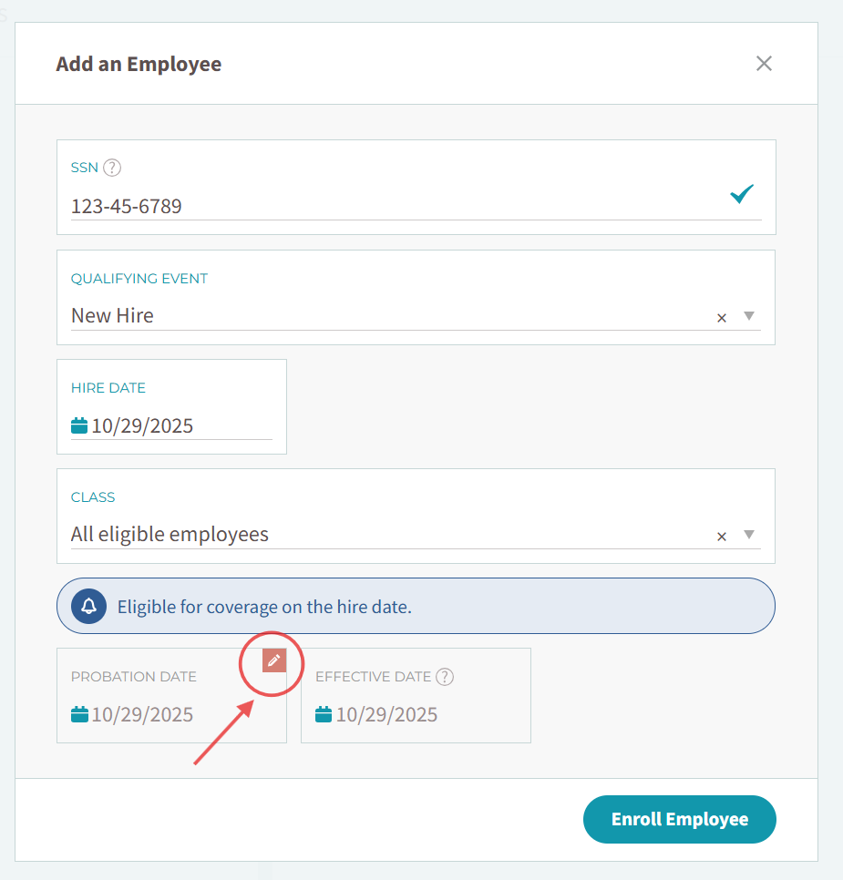
  - Enter a new probation date and an override reason. 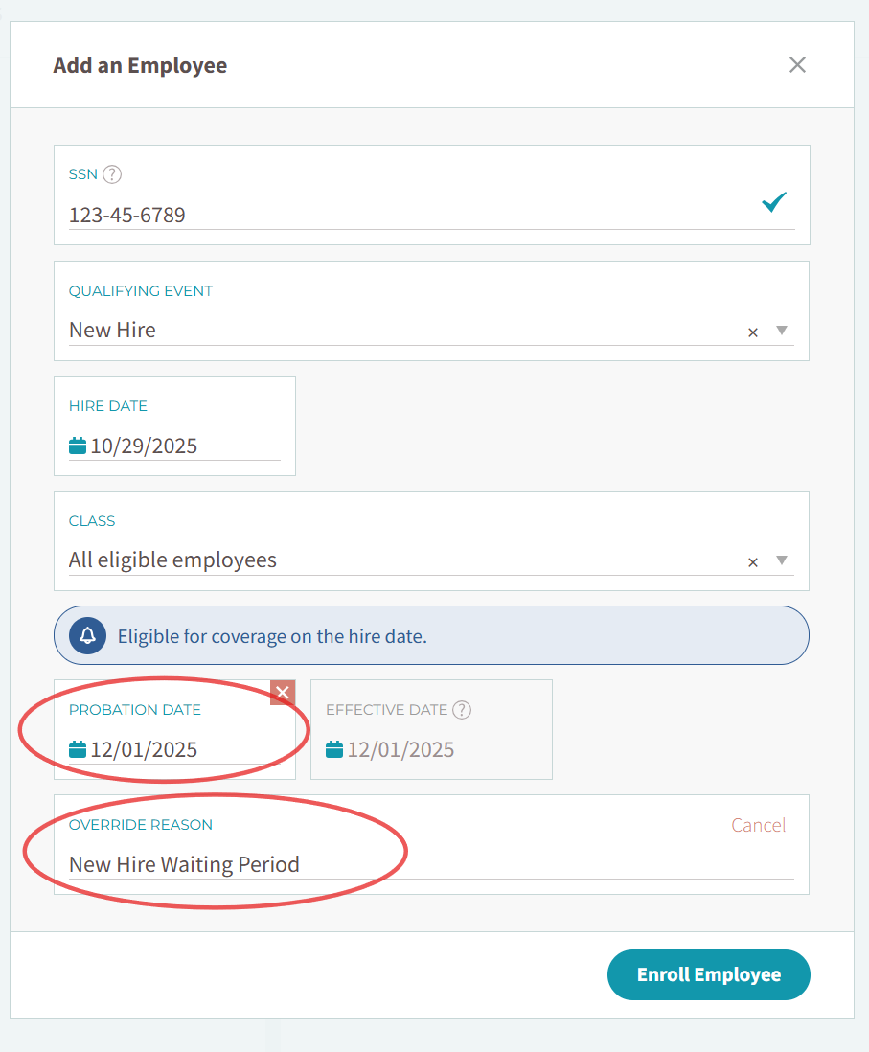
  - Click on the enroll employee button. This will then route you through the standard workflow to select benefits.

